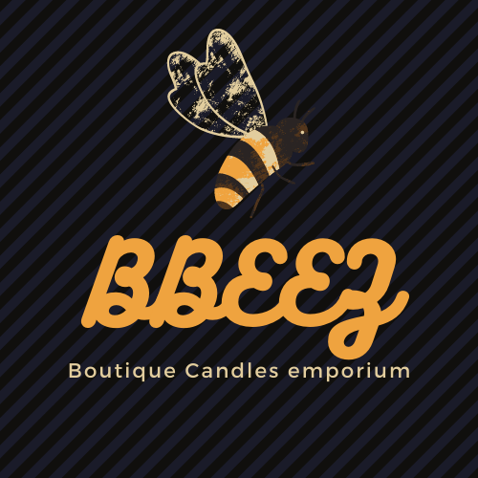  Business and Marketing plans  RECYCLE-REUSE-RELAX | Tracie Walker  bbeezboutiquecandles@gmail.om

Table of Contents
Company overview 2
Company mission, values, and vision. 2
Who am I? 3
My journey 4
Recycling service 4
Sales 5
Team or employees 6
The service 6
The products 6
Short term goals 6
Long term goals 7
Market Industry Findings 7
Driving factors 8
Consumer needs (target market) 10
My Target market 11
Buyer/consumer persona 13
S.W.O.T & T.O.W.S 15
Financials 17
Marketing mix 19
Product (see costs above) 19
Place 19
Price 19
Promotion 20
Projected sales forecasting 21
Competitors 23
Direct competition 23
Indirect competition 24
Collaborations 24
Sustainability and accountability 24

Company overview

Company mission, values, and vision.

Here at Bbeez we want to be as Eco-friendly as possible, its not a marketing ploy or a promotional spin, but a real, genuine effort to do the least damage to the planet, and produce beautiful, quality items that our supporters enjoy.
We want to be a guiding light for others to follow and be a source of inspiration for wanna-be recyclers.
As the founder of Bbeez, I am passionate about being mindful of the environment and making societal change towards a more sustainable, circular economy and taking the urgent steps necessary to make the world a better place for our children and grandchildren.
As a small independent business, we have limited resources for research and development of sustainable production of our products, but will always make it a priority to try to provide the most enjoyable products within our capabilities, without compromising on cost or quality.
We aim to use ingredients that are vegan/vegetarian friendly, Non GM, and grown sustain-ably wherever we can, and will label and describe products with this information.

Bbeez means to make buying luxuries like scented candles into a more
My research has shown that there has been a huge increase in the use of fragranced candles, globally. The mass market are consuming thousands of scented T-lights and jar candles and most of the waste from the sales is going straight into the household dumps.
Social and environmental sustainability are rapidly becoming a more central consumer need in HDHT and in the candle segment.
Millennials (soon to be the dominant consumer group) are listing climate change as their major concern and want to buy products that contribute to a better world. Sustainability related to consideration for social and environmental issues in the value chain. This indicates the use and sourcing of raw materials, the processing and manufacturing, transport, consumer usage, waste, and disposal.

I want Bbeez to take a holistic approach to sustainability, taking proactive steps and partnering with consumers in a quest to give back to the environment.
The drop off service will provide a much-needed option for the recycling of aluminium and glass products, reducing waste and the need to use our dwindling natural resources. The products manufactured from this service can deliver the same quality and appeal as products currently on the market but without putting a strain on the environment
I have planned a packaging and shipping process that aims to use only eco-friendly suppliers and keep transportation to a minimum.

I hope to create a loyalty programme (for customers) that will maintain momentum and create a community of likeminded individuals and businesses. There will be an ongoing goal to collect enough aluminium to build a jumbo jet and/or other similar goals to illuminate the difference we can make when we work together.

I have been unable to find another similar service or product in today’s market. I hope to lead the way for other businesses to find new ways to influence consumer spending and offer consumers easy options to change the way they spend their money. There is no reason why we shouldn’t be able to continue using home fragrance wax products without the guilt of using up our natural resources and gain satisfaction from contributing toward a better future and a lower carbon footprint.
I am filling several gaps I found in the home fragrance decor industry, some potentially profitable and mutually beneficial for multiple groups.
My research has shown there is a thriving growing industry with everything from self-employed through to multi conglomerate companies, with new businesses popping up all the time, all cashing in on the current trend for mood enhancing home improving products, as we all spend more time there and as online shopping increases.
The problem is how to stand out from every other candle maker, The eco-conscious and planet friendly candle producers are competing with the luxury artisan boutiques, you are looking for splashing out on highly priced products or you’re looking for value with quality, but willing to spend more for extra benefits. The eco candle shops attract neither type so cannot compete.
There is no one offering the middle ground option, offering a luxury, handcrafted product that is priced reasonably, covering costs, and giving quality. Nor is there any other recycled candle container shop anywhere.

Who am I?
I am a 50-year-old Mum and Grandma.
I have been reading Tarot cards with a 99% success rate for 30+ years. I am a wiccan and love to study philosophy.
My professional experience is wide, and my knowledge is varied. My first vocational passion was in make-up and hair styling, I was freelance until motherhood took over. I have loved learning since I started reading before I even started school! (I think I was born reading) I began working freelance, selling body shop products, party plan, demonstrating in people’s homes, and selling at fairs. When my duties at home became too much I began working from home as a freelance virtual assistant, I applied for jobs beyond my skill set and learned on the job as and when. This put me in direct contact with employers ranging from entrepreneurs to small business owners, I became an indispensable source of back up administrative and clerical support for these employers, learning much about the world of business in the process.
My passion for my work as a make-up and hair stylist had taken a back seat for my kids.
By the time I had time on my hands again, I was never going to catch up with new make-up trends, but I discovered another way to express my creativity in producing homemade candles.

My journey
I wanted to buy a specific size and colour candle at an affordable price, in a few my requirements and without high postage…impossible. I then concluded I would use a kit and make them as and when, I enjoyed the process so thought maybe I could try selling some on the markets where I couldn’t get them myself, I realised I needed to run multiple tests before I could guarantee my products so I was recycling the tin holders and wanted more so I posted on Facebook for anyone locally throwing them away, this post received 1500 reactions! Over 500 comments and hundreds of messages, over 10 messages a day! See fig 1. I soon realised I had tapped into an endless mine of eager donators who also wanted to try the recycled product their empties had produced. I spent months responding and discussing customer opinions and the idea grew. I am naturally creative and could be called a nature lover, environmentally conscious and charitable. I got excited at the prospect of recycling so much aluminium and glass, I imagined my idea leading the way for similar businesses and making a real difference to our carbon footprint, reducing household waste, and saving the planet, saving my business money, and saving I began trying to reuse the wax left over in the jars and found this could be recycled too.
I have spoken to several eco-stores and successfully secured one of them to stock my recycled candles, they are also happy to be one of the drop off punts for donations. This is an encouraging sign as I have only contacted a small number of potential collaborators, I have also agreed a drop shipping deal with another candle producer, I will promote his products on my sites and receive half the buying price without having to spend anything on stock or shipping.

.
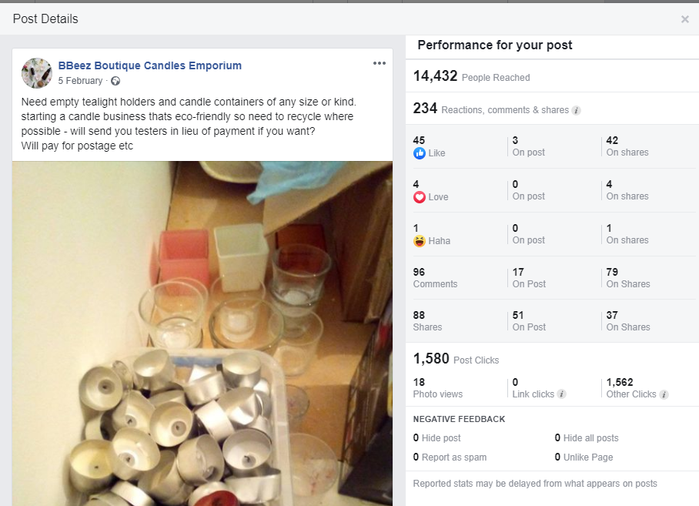
Figure 1

Recycling service
Potential logistics for collecting recycles.
- Drop off points situated in towns and districts everywhere.
- Eco-shops, other businesses.
- A willing member of the public to receive donations in local areas
- A courier service to collect on a large scale, planned so that the route is economical, in order of place on the map.
- Postal service
- A driver employed to collect from different areas every trip, planned logistically with map
- Collected by a local driver

I was inspired to start the business after seeing the reaction that my fb post received, I was shocked and a little moved by the interest that people have in trying to do the right thing, being more mindful of our environment, making efforts towards recycling and reducing our negative impact on the planet.
When I began talking to them, I really wanted to collect every single offer, I envisaged a massive number of containers, many being saved from the household waste, and the thought that something I started might have some positive impact on the current situation. I became more passionate about making this possibility into a reality and my journey began
It goes without saying that any efforts towards recycling are welcome in today’s world, there are many people who dont recycle as a norm, many who want to begin and many who want to increase their efforts, this was obvious from the feedback, it seems that most candle buyers are thinking about being wasteful when they are consuming wax products, they are hoarding the empty holders and dislike chucking them away, I have no doubt about the success of a recycling scheme to collect them, and the supply is unlimited, as they are usually replaced after use.

Sales
In the aftermath of corona virus, the population has moved many of their tasks online, banking, meetings, shopping, and entertainment. The statistics show that the online marketplace is still growing and estimated to continue, the dominant consumers, Millennials have grown up with the internet of things, they are using social media to influence their buying decisions and the interest will increase as the next generation joins them.
My research shows that fb (and Instagram) is leading the way for online sales of this generation, the research says that users want to see more video and photo-based advertising and content.
I will run a content marketing campaign across all platforms, adjusting the content for each one. I think that my story, journey and experience will be something that will interest users, I believe I have only slightly scratched the surface of potential customers and donors and expect a rapid growth on both fronts when the business is launched, for that I need to find adequate funding, without it I worry I will struggle to maintain the impetus, unable to buy the necessary items or pay for essential services. I will be extremely disappointed if I take so long getting started that someone else pick up my idea and run with it.

If you care to follow the news about climate change and the loss of natural resources, you will see that this is a perfect time to launch a service/product of this kind. As it will be eco-conscious in every possible way throughout the business, I will be following the needs and future demands of consumers, who want to make more ethical and environmental buying choices.

Team or employees
I will be taking care of every department however If I am successful in finding adequate funding, I will employ at last two or three members of my team:
- A website/shop/blog manager to update and maintain this and all social media platforms.
- A driver with transport – To begin collections at a local level
- A marketing manager to promote the recycling/collection service and advertise the retail products B2B and B2C

The service
There will be local drop off points, initially in the UK, where members of the public can leave their donations of used wax products including:
- Empty T-light holders
- Used glass jar candle containers
- Used tin candle containers
- Leftover wax from used containers
The bins for donations will be located at either other eco-conscious business, my candles stockists, or businesses that consume large quantities of candle products, these can be collected in an environmentally conscious transportation method.

The products
The donated products will be recycled and repurposed as wax candle products. Including:
- Recycled wax melts from leftover wax
- Recycled T-lights from used holders
- Recycled jar candles from used jars and tins
- The above products using newer raw materials
- Standard plain tapered dinner candles.
- I will be selling essential oil candles, essential oil blends, sweetie scented, cookery scented, floral, herbal, and designer dupe (designer fragrance inspired.)
I am in a perfect position to promote my candles to the donors. I have a database of over 200 people that were a result of the Facebook post, I have spoken to ¾ of them and learned that my product is something they want to see, they are interested to try a recycled candle product for the experience plus they are donating, so a double whammy of satisfaction guaranteed for customers. Giving them a competitive price will be the triple threat for competitors, I should be able to reduce my production costs enough to allow me to price accordingly, I recognise the worth of the product as it is still handcrafted, unique and luxurious so I want to make the price reflect these features.

Short term goals
- Find drop-off points locally
- Build contact list/leads
- Build an online presence and shop – increase traffic
- Create a recycled brand of wax products
- Produce recycled wax products from donations
- Sell products using e-commerce and social media – grow reach
- Build a community of likeminded individuals and businesses
- Build brand awareness and reliability
- Illuminate the eco-issues and aim to impact in a measurable way

Long term goals
- Expand product line: some ideas include massage candles, candles for the occult product industry among other plans
- Make a nationwide logistics plan for collecting recyclables
- Start drop shipping for collaborating suppliers
- Meet recycling goals as a collective
- Attend events/fairs/markets
- Expand collaborations
- Stock in more outlets
- Larger workshop
- Professional internet marketing advice
- Employ company transport for collections and deliveries

Market Industry Findings
Home fragrance
Segment
Candles
Desegmentation
Scented wax products

The figures available on the revenue potential for the scented candle market suggest approx. ¾ of us buy them and there is opportunities toprofit from the online consumers and social media users. I believe my usp and the current trend of buyers uing their spending power to force companies into offering a better deal for the planet, put me in an ideal position to fill that gap, I just need the correct backing and support to take it off the ground.
I
The global home fragrance market was worth $22.9 billion in 2019 to reach $27 by 2027, the candle segment share at 35.8%, and growing due to increasing demand for innovative and aromatic candles for gifts., the European market expected to gain significantly as spending on homecare rises.

The global candle market was worth $3.45 billion, and the global scented candle market is expected to reach $645.7 million in 2026 rising at 11%.
If we use the amount of non-store-bought sales from fig 2, which is 36% of the global candle market ($3.45 billion) this equals approx. $1,24 billion sales revenue, for the market share
In the table below, the portion of scented products bought online was approx. 1/6 of the market share, fig 3 it totals $207 million total available market
If I estimate the number of competitors online at 1000 competitors, we will make an average of $207,000 in revenue from the potential target market, if there were 10,000 competitors, the potential sales will be $20,700 annually. There looks to be a potentially healthy profit margin.
The UK candle economy is worth upwards of £1.9 billion, with small businesses reporting an increase of 71% and 33% on the previous year (2016)
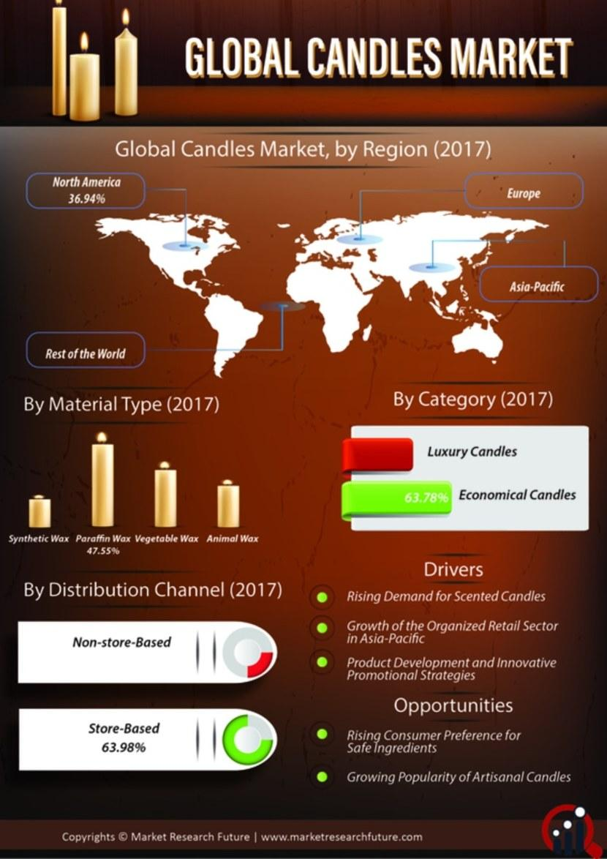
Figure 2

Driving factors
The commercial value has seen significant growth due to the popularity of use in health centres and spas, fine dining and restaurants, and the use in religious ceremonies, celebrations, festivals, and get together s. There is also a large demand in traditional and spiritual practices.
the market will gain more traction as people give more importance to the enhancement of homes and the positive effects of scented candles including removal of unpleasant odours, boosting energy, mental focus, and assisting a better immune system. Greater opportunities for candle businesses as people spend more time at home and their surroundings become more important. Fig 4

Candles are used as a focal point in the home or used for aromatherapy, 42% in their living room, kitchen 18% and bedroom 13%.
According to a survey of 1001 people 42% used them to make their home smell better, 34% to relax them, and 34% to feel cosier, with 13% using romantically and 1 in 10 in the bathroom.
Most people agree candles are an appropriate gift with 76% buying as a holiday gift, 74% as a housewarming gift, 66% as a dinner party gift, 61% as a thank you, and over half 58% as a birthday present.
Women, 70% have bought candles in the past year, followed closely by 53% proving both sexes enjoy candles regularly. Purchases are higher among 44 years old and younger, larger incomes
larger purchases, an average income of 35 to $4900 where 70% have been made this year.

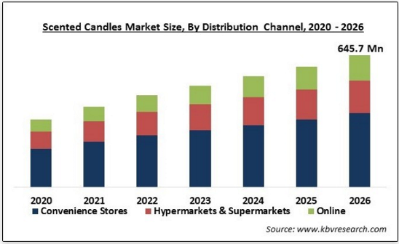
Figure 3
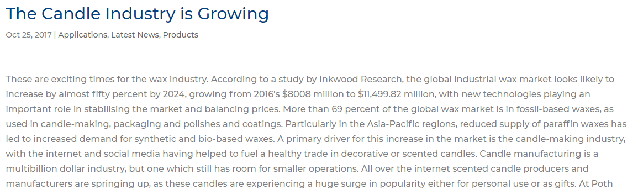

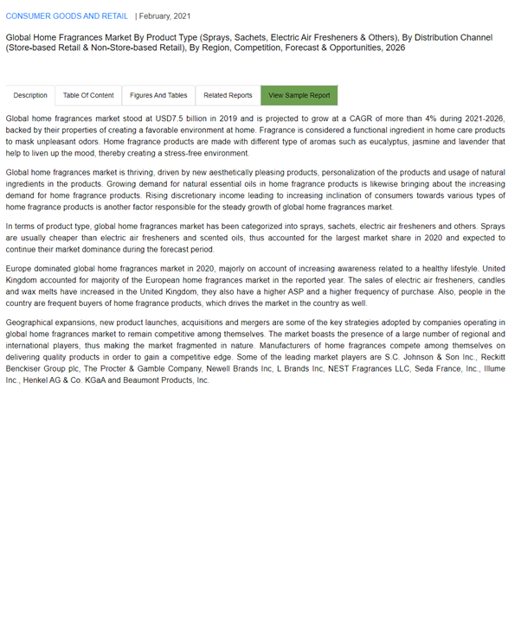
Figure 4

Consumer needs (target market)
Consumers hunger for more unique products, the "Chore or Cherish" trend in retail reveals people will buy mass-market produce for some items but for something special, to cherish, they will turn to the more independent, specialist retailer. The most important factors. the scent, colour, cost, and shape, with fragrance coming in the top 3/4's of needs, as being extremely or particularly important when selecting a candle product.

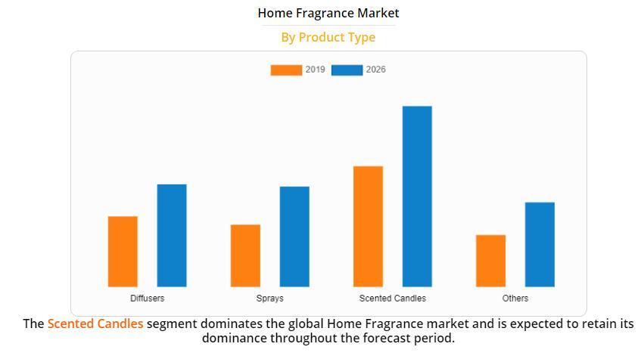
Figure 5

My Target market
Who is my target market and why, how are they buying?
Millennials were born between 1981 and 1994/6. They are currently between 25 and 40 years old (72.1 million in the U.S. alone. In 2020, approximately 1.8 billion people worldwide2, or 23% of the global population, can be considered as belonging to the millennials Marketing is being shaped by social media influencers. See fig 6
This generation see their homes as an extension of their personality or what they aspire to be, they have value sets related to sustainability, social equality, and diversity.
They want their brands to stand for something, this places them on the higher end of mid-market.
The pandemic increased the importance of sustainability at a basic level, rather than consuming les they want to consume better, as people become more aware of their consumption, they are trying to produce less waste. Companies are being held accountable for their value. Concept relating to recycling and upcycling are very welcome in this market, already representing the working population dominant consumers for the coming decades, the millennials sense of urgency and activism, and their belief that they can make a positive influence through their purchasing behaviour means this trend will be a central part of future HDHT industry. Which will be further stimulated by the “European green deal” to be climate neutral by 2050.
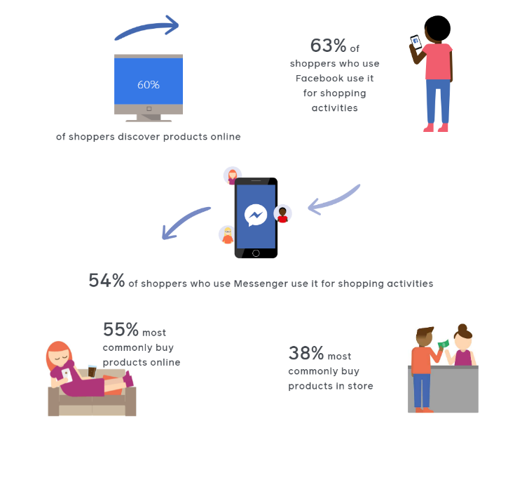
Figure 6
My focus is on the ecommerce market, this is the current market where the most growth is expected, it is driven by the millennials and increasing incomes of generation x, research shows that millennials will be the dominant buying force over the next 5 + years. I have found evidence that they will be using the internet increasingly and they are using it to influence their buying decisions.

Here are some compelling statistics.

- 2.7 million active monthly users of Facebook
- 1.6 billion follow a small business page
- There are 90 million business pages
- 15% of users find purchase using Facebook marketplace
- 38% of U.S shoppers want to increase shopping by smartphone
- 85% of orders are made from social media on Facebook
- 38% of shoppers look for/find new products using Facebook
- 83% of users find new products using Instagram
- 54% make the purchase as or just after finding it on Instagram

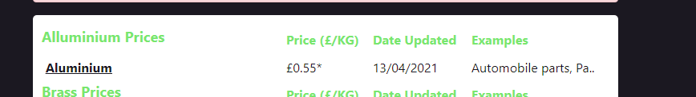
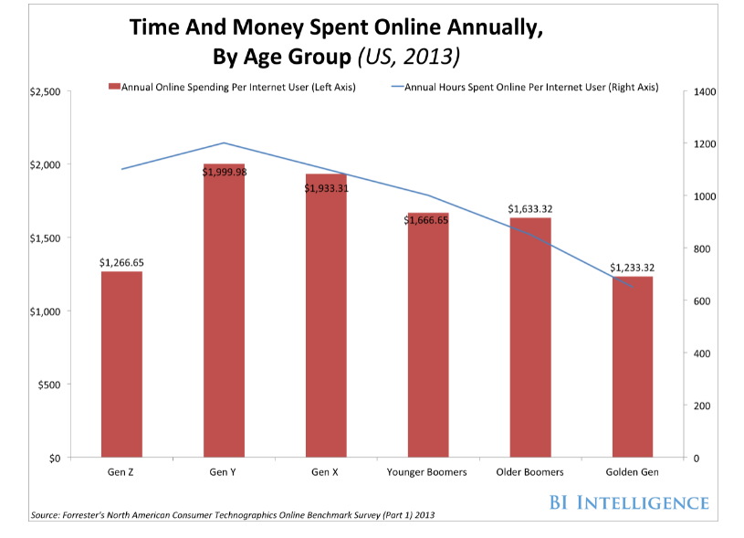
Figure 7
I will create a business website and blog about recycling candles. I will have a google site for the business improving my place in search engine searches.
I will also create a Shopify store linked to my business social media profiles on:
Pinterest
Twitter
Instagram
LinkedIn
And I will post my products for sale on selling sites such as:
Etsy
eBay
Amazon

I will take every online advantage available to market and promote the business. The more profiles I create the better and wider the audience I will reach, and the business will appear in searches more often and higher up.

Buyer/consumer persona
Millennials are the main target for my products.
 |  | Marital status | Income
Millennials | 18-30 | Single | £20-35000
 | 25-45 | Couple/married | £25-45000
 | 30-65 | Parents | £30-65000
Millennials surpass baby boomers as the largest living adult generation in 2019. This means that millennials make up a huge percentage of consumers and have immense buying power. It was estimated that millennials will spend $1.4 trillion in 2020. See fig 7
This does not take any buying power from the other dominant spenders of Generation X, Y and baby boomers. See fig 8
Mainly female | Aged 18-60 | Living in a rented accom | Living as a couple | Working in low-income jobs i.e., admin
High % of males too | Enjoy going out | Buying first home | First mortgage | Joint income
Married couples | Like to buy gifts | Interest in home decor | Interest in interior design | Maybe planning family
Single people | Environmental activists | Eco-friendly products | Cruelty free | vegan
Couples with children | Enjoy enhancing surroundings | Improve home & garden | Attention to health & wellness | Use holistic treatments
Med-high incomes – small business or self-employed | Follow traditions like b’days & xmas | Want to reduce bad aroma or create good aroma | Like to be surrounded by nice objects and smells | Use aromatherapy

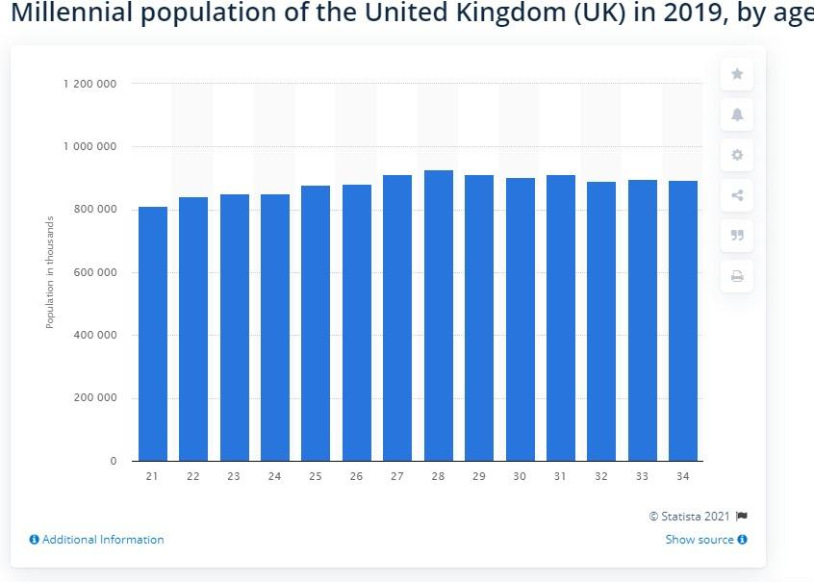
Figure 8

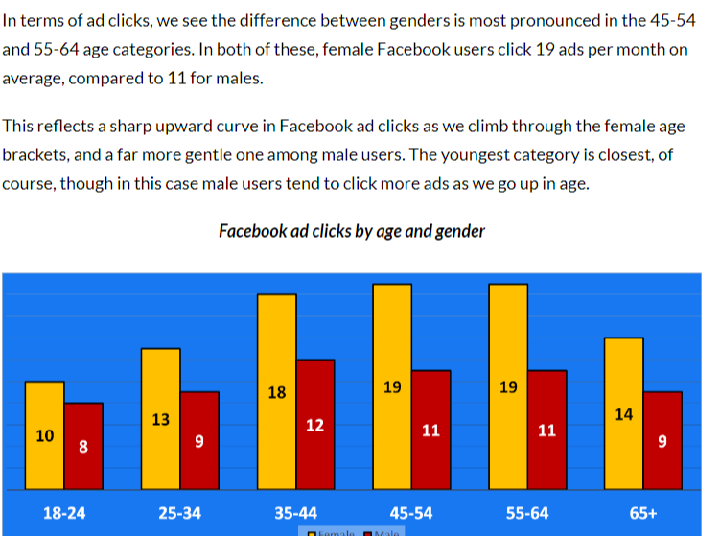
Figure 9

S.W.O.T & T.O.W.S

Strengths:  - My passion for the goals to focus on recycling rather than profit.  - My experience in clerical, retail, and home-based business.  - Maturity.  - Good product.  - Great customer service attitude and experience.  - Personalized service and products.  - Good at creating engaging social media interest.  - Can reduce waste by making orders instead of making them in advance.  - Potential for start-up funding.  - Can expand on products, depending on stock of donations.  - Can sell accessories – possibly cutting out the additional shipping by ordering delivery directly from the supplier?  - Good company values and beliefs.  - Good researcher.  - Creative talents.  - Extensive experience in several helpful industries. |  | Weaknesses:  - Hard to separate work and leisure work from home.  - collecting donations without transport.  - no Start-up experience.  - Workshop and equipment need improving, professional, bigger Melter, additional equipment required.  - design and product marketing inexperience and lack of skills in photography etc.  - inexperience in promotion and marketing on social media.  - lack of funds.  - Need staff.  - Possible quality control problems as donated wax is unknown.  - First time starting a new business.
Opportunities:  - loyalty benefits scheme for donators.  - Unique product and service not available anywhere else.  - Growing market forecasts in industry.  - Aligns with current environmental attitudes which might encourage both public and businesses to use us.  - Opportunities for expansion into other products for the home and health.  - Customers waiting to donate and purchase recycled products.  - Target market aligns with marketing plans, and the secondary market will be growing more profitable.  - Potential for future funding.  - Skills transferable from beauty industry, market research, virtual assistant and hairdressing, also skills from several home-based jobs, freelancer and body shop at home consultant. |  | Threats:  - Safety and insurance obligations.  - Business support and guidance needed.  - Bigger brands stealing my idea/competition.  - High postage costs both receiving and delivery.  - Not meeting sales demands due to inexperience.  - Ineffective promotion affecting sales.  - Safety or quality might be an issue.  - Inconsistency in result due to unescapable differences in recycled wax risking customer dissatisfaction and bad reputation risk.
TOWS
 | Opportunities  External positive |  | Threats  External negative
Strengths  Internal positive | Strengths–Opportunities. Use your internal strengths to take advantage of opportunities.  - On current trends for sustainable consumer demands so building brand reputation.  - Millennials are seeking eco products and companies.  - potential for collaboration with like-minded businesses |  | Strengths-Threats. Use your strengths to minimize threats.  - Consider using temp experts from fiver etc. before employing the permanent staff required prior to launch to reduce costs & ensure all areas covered.  - Use efficient R & D habits to record all methods used so easily repeated for optimum results in production.
Weaknesses  Internal negative | Weaknesses-Opportunities. Improve weaknesses by taking advantage of opportunities.  - Utilize all Facebook and Instagram and shopify marketing tools for success.  - Take any opportunity to train and learn necessary skills and when. |  | Weaknesses-Threats. Work to eliminate weaknesses to avoid threats.  - Use inconsistency in production as a positive feature - every recycled candle produced is 1 of a kind.  - Learn and follow all statutory regulations.  - Take out necessary craft insurance.

Financials
This cashflow is based on three months, I have estimated a £20 sale per day for each sales channel. I have decided to underestimate as I do believe that this is an easy target to reach. Research shows that shoppers online spend at least £20 per day on purchases.
Table 1
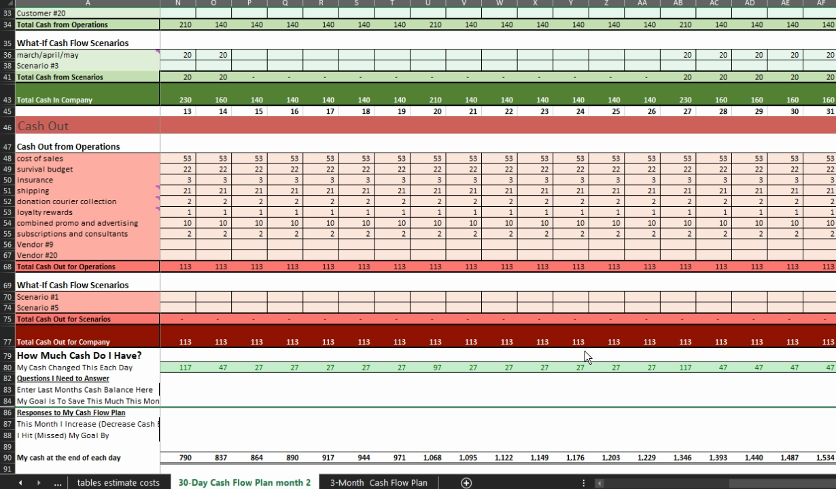
CASHFLOW 30 DAY
Table 2
Estimated production costs for 10 recycled floaters/10 recycled tea-lights/6 recycled melts/from new tea-lights.

Marketing mix

Product (see costs above)
My customers want to enjoy home fragranced wax products by buying in an eco-conscious way. They demand they are produced and manufactured in a people and planet friendly fashion. They want quality and value; they are prepared to pay more for something that meets these needs and offers them extra; contributing to reducing landfill and carbon footprint. The additional benefits of the recycling service offer a way to recycle their purchases and enjoy them once again.

Place
They will be able to find the products online, on all their usual social media platforms and via online stores like Etsy and eBay. See fig 9
I will be creating content to attract my customers according to their likes and interests. There will be a website and blog (linked to the store) to keep them informed and up to date on all new products and our philosophy and mission. I also plan to take my line around local craft fairs and markets, offering raffle prize etc when necessary.

Price
The above picture shows there is potential for profit from the recycled products. The products will be priced at a low to medium price point, I want to pass on the savings from recycling to my buyers, particularly loyal donators who will receive discounts and rewards from their efforts. I want to offer quality recycled goods that do not differ in quality from made from new products. In the above table I have calculated estimated costs of producing the recycled products, and the table on the far right is calculated using cots of new products. The cost nearly doubles. I have been unable to purchase raw materials in bulk so some costs might reduce when I can buy more economically. I will also have the products in shops from any collaborations, to show how my products compare in quality and price.

Promotion
I will utilise social media marketing tools like Facebook ads and Instagram shops. Every sales channel will be linked to the shop, and I will run promotions and loyalty schemes to encourage both recycling and retail. My customers will understand that every recycled product is uniquely created using the raw materials in stock, this will be an asset to the business producing one-of-a-kind products. I will have collaboration with suitable businesses so that there will also be more repeat buy products on offer. I expect the recycling service to serve as a promotional tool for the recycled products every drop off point will be an advert for the shop. Many of the drop points will also be eco-shops on the high street so this will increase reach and profits. They will be promoting my business to heir customers also

Collaborators include
- Newsome candles https://candles.org.uk/ - drop shipping, listing my business on their website as a stockist off their products
- Lincolncopantry.co.uk – stockist and drop off point
- http://thezerowasteshop.co.uk/ - drop off point

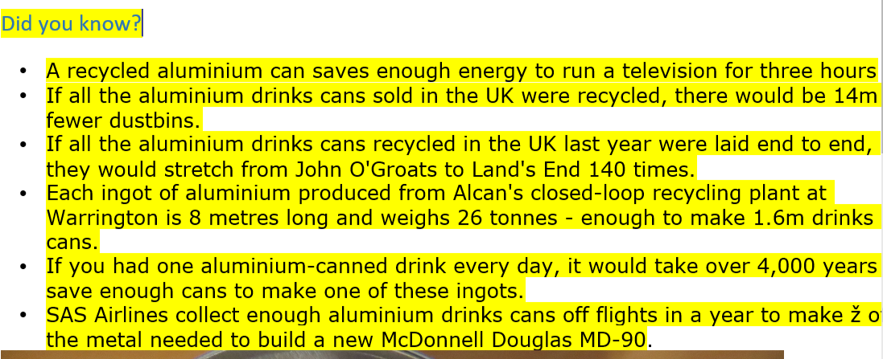
Table 3
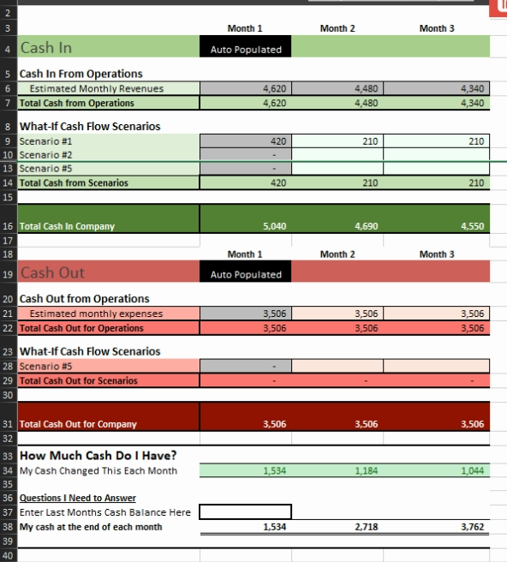
3-month cashflow projection

Projected sales forecasting
I have based my sales on the expected growth in the fragranced candle market.
It is reported that 70% of Brits (of which 630.000 are millennials) buy a candle product costing £15+ at least 10 times every year, which adds up to a lot of candles being purchased every year, this number is expected to keep growing for the foreseeable future. Projecting sales is utterly impossible given so many variables, my confidence is based on the growth in online sales in general and the upward moving trend for all things green.

The sales of candle products fluctuate at different times of the year including traditional holidays such as:
- Halloween
- Christmas and New year
- Easter
Seasonally:
- Winter - more time indoors- create an atmosphere, etc
- Summer - insect repellents
People also buy candles at specific events such as:
- Birthday celebrations
- Dinner events
- Gifts
And candles are purchased for other situations such as:
- To relax i.e., bath time
- To remove unpleasant smells
- To decorate an area in the home
- For spiritual practices i.e., yoga or meditation
Many commercial businesses use candles regularly like Spa's and health retreats or bars and restaurants.
I expect sales for my products to increase around the times described and others not specified.

My research has exposed a highly lucrative and profitable market that has been growing steadily over the last five years and is predicted to continue growing.

Competitor Analysis
Competitor analysis grid
Table 4
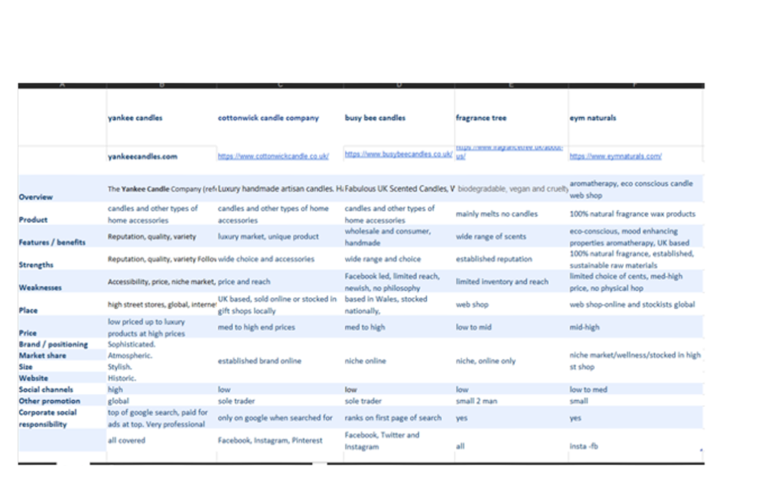

Competitors

I have selected 5 competitors to compare. Both direct and Indirect competitors. These are a good example of the different types of businesses that are currently in the marketplace. From a large multinational organisation with many other companies within it to a small sole trader selling primarily online.

- Yankkecandles.com

- Cottocwickcandl.co.uk
- Busybeecandles.co.uk
- Fragrancetree.co.uk
- Eymnatural.com

Direct competition
I would suggest there I not a definitive direct competitor as there I no other business combining this service with this product; therefore, I have chosen the businesses with other aspects that mirror my business.
The most direct competition will be from businesses sharing similar people and planet friendly philosophies. This is where I need to focus, by exceeding their efforts and promoting this when marketing the recycled products. I also have an advantage from providing the recycling service where they do not offer any recycling features. It will also be important to utilise all social media platforms and their marketing tools, as some businesses use only one or two channels online. I will have a large advantage in less outlay for raw material as I will be re-purposing the donations, this gives me the opportunity to provide the quality of product expected at half the cost, I will pass the financial savings on to my customer by offering discounts and loyalty rewards, for regular donators and loyal customers. The information gleaned from studying and noting the type of candles being donated will give me invaluable insight into consumers preferences.
As I plan to include drop shipping (products matching our philosophy) and stocking my products in the eco-shops in my sales plan; I will widen my inventory and choices for buyers.
My competition will mainly be found online, the market is saturated with home-based handcrafted candle businesses, which is why my product stands out as a combined service, as it recycles the products on sale, this will be an especially important promotional advantage in reaching consumers, it will allow me to reach a much wider audience including everyone interested in eco-products and saving the planet in general.

Indirect competition
There will be indirect competition from the more established and well-known brands and shops. There are only several businesses that offer any kind of recycling for their products. There is no-one making new wax products from containers or upcycling any of their products after use. My recycling service relies on the bigger more popular candle manufacturers and retailers to provide the empties and leftover wax that I need. I will offer the most popular types of candle products to reach the widest market, as well as creating many unique products that cannot be found elsewhere and cannot be repeated due to the nature of the production process, as I will be using different colours and decorations for every batch of wax product I make.

Collaborations
I have contacted a variety of relevant businesses to find suitable drop off points and possible stockists, approx. 50/60, and I’m very pleased by the reception, I have secured one eco-shop in Lincoln to stock the candles and provide drop off for donations, this indicates that further work on lead generation could produce positive results, and also provisionally agreed on a drop shipping deal to promote some luxury products, that align with our ideals, for another candle producer, I will avoid costs of stock and shipping and receive half the purchase price.
I have several other potential leads to follow up at the right time, I am ready to take the business forward as soon as the finances are available.
While researching competition I only found a recycled wax shop that takes wax from churches etc and creates candles from that, in the high end of the market and a couple of retailers with bring back your empties for nothing schemes, but nothing substantial.

Sustainability and accountability
I hope to source sustainable, eco-friendly materials and use ethical and conscious methods in all levels of the business. I will tweak and turn every possibility on offer to try and maintain a luxury, quality product, and operations will aim for the same. I
The USP – Unique, 1 of a kind, wax product will bring some challenges to overcome.
As I will be using donations, the range and type of container is unlimited, I do not have multiples of the same one, I will be making one off creations, they will be promoted and when it sold there will be no more. This could be seen positively or negatively.
PRO’S | CON’S
Unique, one off products | Upset buyers unable to repeat purchases
More personal | Labeling issues
Its already been bought once so probably sell again | Testing issues
Consumers get a product no one else can buy | Reliability of behaviour of burn
Might be more profitable | Used might put people off

Branding – business impressions
I have created examples of business graphics for cards and labels.

LOGO 1
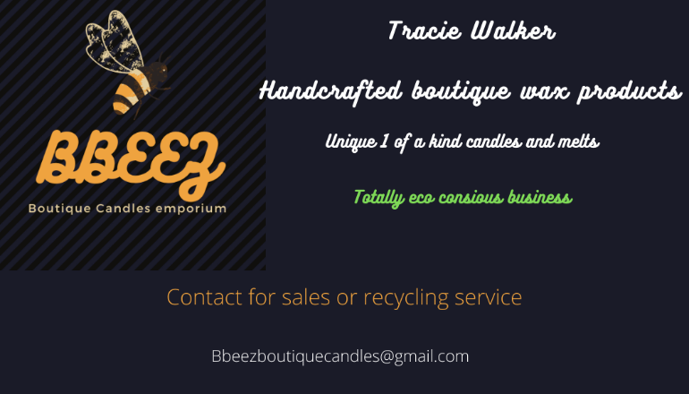
BUSINESS CARD 1

